2018 – 2019 Villawood Properties Tri Series

Race Marshals Roster
Race Marshal Duties for each race are specified as per the letter beside the race marshal’s name. Please familiarise yourself with the mandatory requirements and specific individual tasks as set out below to ensure the safe and smooth completion of each event.

Sunday 16th September Race 1
BBQ Jay Sanderson & Vicki Lane
A1 | Michael Gibbons | A | Mark Lees | B | Lyn Sebire
C | Roy Preece | D | Dugald MacKenzie | E | Trinity Sanderson
FA | Jason Carroll |  | Greg Croft
Sunday 28th October Race 2
BBQ Janine & Graeme Holland
A1 | Mark Lees | A | Murray Hyde | B | Liz Riddell
C | Adrian Ryan | D | Dale Lowe | E | Trinity Sanderson
FA | Donna Todd |  | Andrew Johns
Sunday 18th November Race 3
BBQ Liz Foster & Jay Sanderson
A1 | Adam Flemming | A | Tim Lovell | B | David Ash
C | Tony McQueen | D | Mitch O’Neill | E | Trinity Sanderson
FA | Megan Goode |  | Louise Murray
Sunday 09th December Race 4
BBQ Liz Foster & Kasey Ludeman
A1 | Geoff Webb | A | Alex Trantor | B | Damien Martin
C | Ben Cook | D | Nathan Mills | E | Mark Thompson
FA | Daniel Kellow |  | Andrea Smith
Sunday 13th January Race 5
BBQ Nic Gilbert & Jo Lythgo
A1 | Steve Monigatti | A | Kevin DeVries | B | Stephanie Rhoden
C | John Taylor | D | Anthony Roberts | E | Jarrod Epps
FA | Cait Fraser |  | Nicholas Tripodi
Sunday 24th February Race 6
BBQ Adrian Barnes & Melissa Douglas
A1 | Markcus Brown | A | Nathan Meade | B | Paul McGrath
C | Craig Kilby | D | Peter Kennedy | E | Roger Bysouth
FA | Karena Spencer |  | Andrew Van Agtmaal
Sunday 24th March Race 7
BBQ Tesarna Lapham & Paula Saxon
A1 | David Cripps | A | Danny Breen | B | Aiden Cushnahan
C | Lenny Cooper | D | Troy Morris | E | Rachel Keene
FA | Sallyanne Bartlett |  | Jason Anderson

Race Marshal Mandatory Requirements
The rostered person must arrange a replacement if unable to undertake their duties.
All rostered persons are to be on site by 6.45 am
Race Marshals are welcome to race on the day (after set up) provided they have arranged for a parent/friend/person to undertake their specified road marshal/corner duties.
Persons undertaking road marshal/corner duties must be a minimum of 18 years of age
Rostered persons under 18 are to arrange a person over 18 to undertake their duty
Briefing / Instruction provided for Road Marshals at rego tent before Race Briefing
Marshal A1 & A |  | Marshal B |  | Marshal C
Assist with Transition area set up |  | Assist with Transition area set up |  | Assist with Transition area set up
Co-ordinate Set Up of Transition area and Road Signage. Check for glass on course & corners. |  | Assist with road signage set up. Sweep course or corners if reqd. |  | Assist with road signage set up.
Road Marshal 1 @ entrance to transition area/carpark on Simpsons Rd |  | Road Marshal 2 @ Cnr Simpsons and Averys Rd |  | Road Marshal 3 @ Cnr Hodgson St & Sailors Gully Rd
Assist with packing up transition area and road signage. |  | Assist with packing up transition area and road signage. |  | Assist with packing up transition area and road signage.
Marshal D | Marshal E |  | Marshal First Aid  (Level 2 First Aid Certificate)
Co-ordinate and assist with set up of registration tent | Assist with Transition area set up |  | Assist with set up of registration tent
Assist with drink station set up | Ensure security of transition area before race |  | Assist with registration and race numbers
Assist with registration | Ensure dismount line is marked and sweep dismount area |  | Complete sheet with mobile numbers of Marshals.
Road Marshal 4 @ Cnr Sailors Gully and Simpsons Rd | Advise riders of helmet and dismount requirements during race |  | Remain near transition area and tend to any injuries or incidents
Assist with drink station pack up | Ensure security of transition area after race |  | Delegate helpers to give out drinks to runners
Assist with packing up registration tent and equipment. | Assist with packing up transition area |  | Assist with packing up registration tent and equipment.
Race Director – Greg Carter – Mobile – 0417 004 227 – Email – gmcarter80@gmail.com
There are normally spectators/members who are willing to assist or be a road marshal if asked
The designated First Aid person is able to race provided a suitably qualified stand in is arranged

Road Marshal Requirements
- Road Marshals are to have a red flag, an orange flag and wear a retro reflective vest
- Road Marshals are to use the standard flag signals. (as per sheet below)
- Road Marshals must not direct traffic but only signal to the riders.
- Road Marshals are to position themselves as per marshal briefing, which will ensure they are visible to the riders, can see oncoming traffic and safe from all traffic.
- Road Marshals are to carry a UHF radio and mobile phone. Exchange numbers with FA marshal.
-------------------------THANKYOU FOR YOUR ASSISTANCE----------------------------

Standard Flag Signals
ORANGE FLAG  SLOW DOWN - CAUTION  VEHICLE OR HAZARD AHEAD  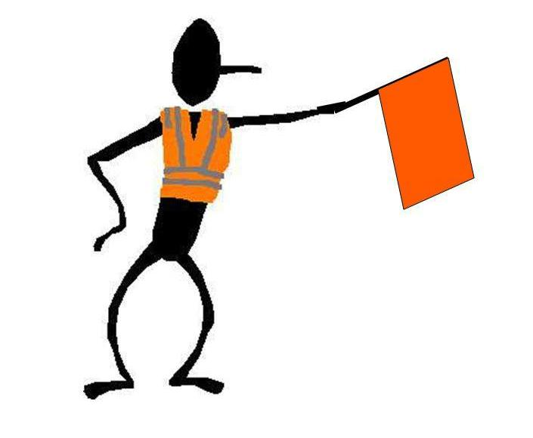 | RED FLAG  RIDER MUST STOP  DANGER AHEAD  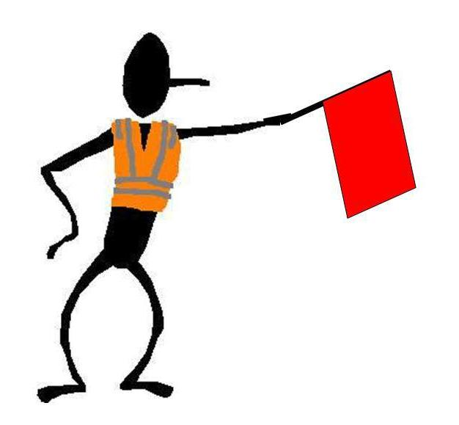
NO FLAG  PROCEED WITH CAUTION | RIDERS MUST  OBEY  ALL  FLAG SIGNALS  AND  ROAD RULES
PENALTIES APPLY FOR DISOBEYING FLAG SIGNALS

